2019-2020 SAT Dates

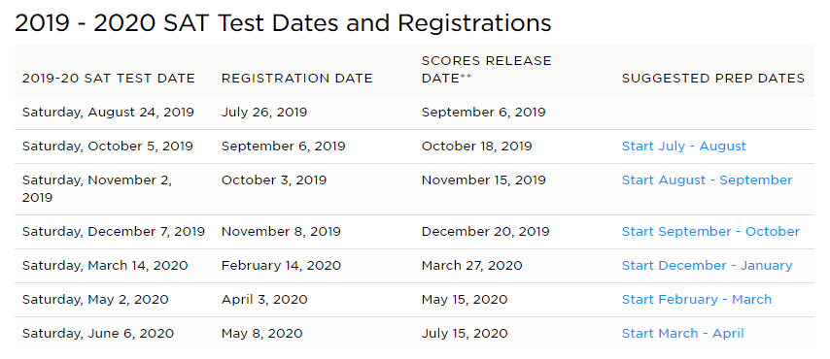

\*If a student is enrolled in the free/or reduced lunch program, they are eligible to receive a voucher for a FREE SAT. This also includes four free college applications. They must see their guidance counselor to receive the voucher. If you have a voucher, any late fees are waived for testing.